

PROJECT REPORT

TASK FORCE

CONTENTS

1. Definition Of Problem
2. Requirements Analysis
3. Design Phase
4. Architecture of website
5. Evaluation/Testing
6. Project Tracking and Monitoring Activities
7. Source code
8. User Guide
9. Site Map
10. Our journey

1.Definition of problem

“SoccerVerse ” is a soccer leagues website to be designed as a web design

A soccer website may encounter various problems, such as slow loading times, broken links, outdated information, navigation difficulties, or inadequate search functionality. A problem-solving approach involves analyzing these issues and implementing appropriate strategies to resolve them.

Additionally, problem-solving on a soccer website extends beyond technical aspects. It also encompasses identifying user pain points and addressing them through intuitive design choices, clear communication channels for support or inquiries, and relevant content that caters to different levels of interest or expertise

2.Requirements Analysis

* List of inputs to the system

In this website “soccer”, Example of inputs would be apperication column in tournament,Clubs,leagues,Feedbacks and so on...

* List of outputs expected from the system

In this website Soccer ,Example of outputs would be player Statistics Data

* Hardware and Software requirements for implementing the project

# **Hardware**

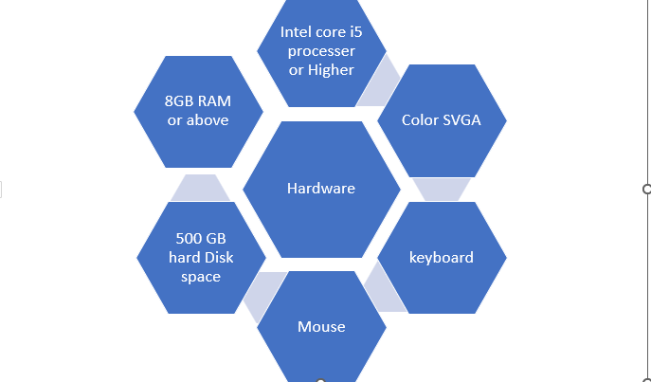

# **Software**

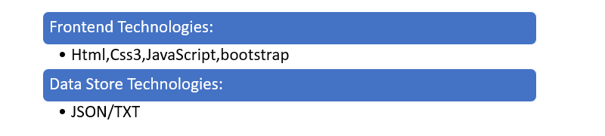

* Customer’s acceptance of the criteria for the project

The acceptance criteria could be following

1. Current Live score
2. User Favorite Player Biographics
3. Upcoming schedule

3.Design phase

Design phase involves the preparation of the blueprint of the proposed system

* Designing The GUI Standard

For “soccer” you must plan and design the user interface using **canva**.Multiple pages must be created and linked to each other.Each of these pages or forms Should have a consistent look with respect to appearance and theme used. The font style, color of the label, design and appearance of the command buttons,the appearance of header and footer and the design size of control,such as checkbox or textbox should be consistent through the feedback and contact us page

* Designing the process modules

1. User Feedback
2. Player Biographic
3. Sorting ,filtering and searching

* Designing Coding standard

You must define and State your coding standards

4. Architecture of Website

* Data Flow Diagram (DFD)
* Flow chart
* Database design

5. Evaluation/Testing

When it comes to designing a soccer website, evaluation and testing play a crucial role in ensuring its effectiveness and success. Evaluating and testing the design allows you to gather valuable insights and feedback, helping you make informed decisions to improve the user experience and achieve your website's goals.

6. Project Tracking and Monitoring

7.Source code

8. User Guide

A)System Requirements

9.Site Map

10.Our Journey of Tehwiz 4

Aptech has been one of the front-runners in IT education

At the 3 days of Tehwiz Competition we got to learn xtra-ordinary The project assigned were challenging and fun.Another excellent point is we were grouped with the Student of Other Batches & got to learn from each other.

Our Faculty member guided us throughout the project and monitored our tasks

Concluding , we would like to thanks Aptech for coming up with this great project idea.

At TECHWIZ we had an amazing experience

11.TaskSheet

| **Name** | **Task** | **Update** |
| --- | --- | --- |
| Fatima  (Frontend) | | Logo design | | --- | | Feedback Form | | Live score layout | | Table layout | |  | |  |
| Muskan  (Frontend) | | Documentation | | --- | | Footer | | Prototype | |  | |  |
| Hassan  (Frontend) | | Navbar | | --- | | contact us | |  | |  |
| Muhammad  Urwah  (Frontend) |  |  |